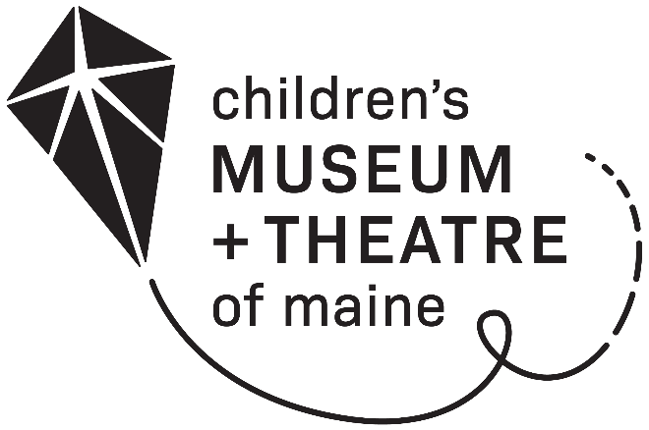
PRE-SCHOOL MEMBERSHIP

A membership program at the Children's Museum & Theatre of Maine for daycares.

Year-Long Pre-School Membership: $450

- Free general admission for up to eighteen children and all staff

- Additional visitors receive a discounted group admission rate

Organization: ____________________________________________________

Contact Person: __________________________________________________

Address: ________________________________________________________

Phone: __________________________Email: __________________________

Please return form, payment and a copy of your preschool license to:

Children’s Museum & Theatre of Maine
250 Thompson’s Point Road
Portland, ME 04102

To sign-up or renew over the phone, please call the front desk at
(207) 828-1234 x290

www.kitetails.org

